Student Insurance Information
1.To access your student’s insurance information online go to our website www.panatlanticfoundation.org and click on High School in America, then Student and then Support and Information.
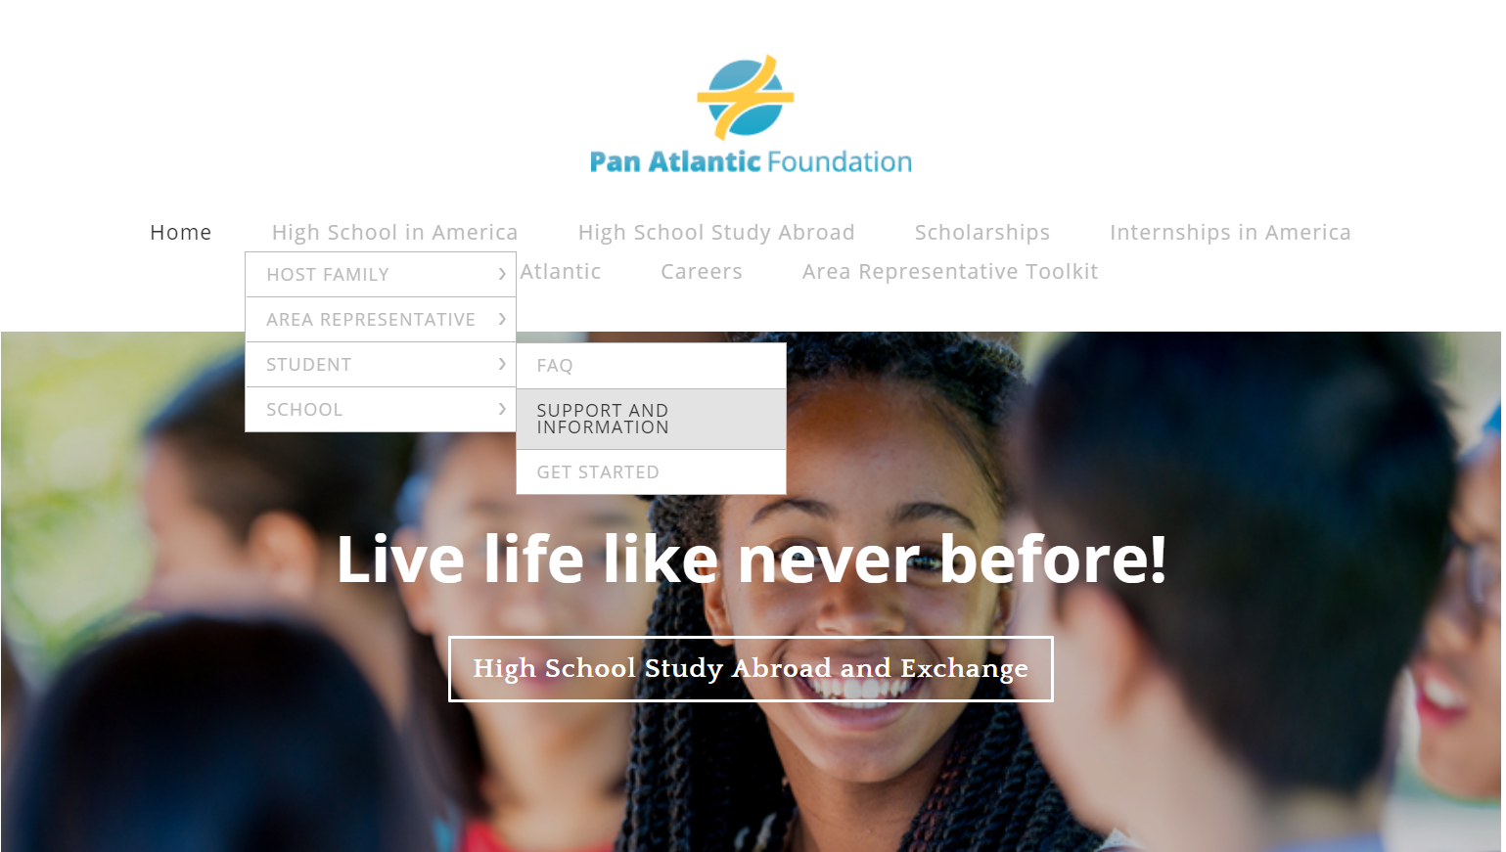
2. When you scroll down the page you will see Student Insurance Providers. Here you can click where it says, “click here” and it will bring you to a search engine where you can search for local providers that take your students insurance. You can also call the provider directly to find the nearest doctor.

3. At the bottom of this page you will find information for Insurance Claims and the Insurance Portal. After your student has visited a medical provider they can submit a claim for reimbursement. This claim must be filed within 60 days of the visit. If you click on (step by step directions here!) you will see the instructions on how to file a claim for reimbursement.

4. Insurance Portal- Every student entered their email address and created a password with a staff member at orientation, so your student should already have an account. Your student can log onto their Insurance Portal to find a provider, make claims and track a reimbursement. If your student has trouble with logging into their Insurance Portal, please reach out to their Area Representative for help.

