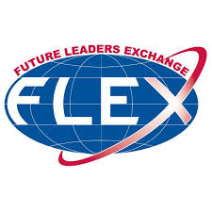
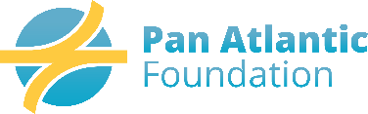
Enhancement Activity Proposal Form
(Form Due 2 Weeks Prior to Scheduled Activity)

AR Name: _______________________ RD Name:________________________ Today’s Date: ______________

Date of Activity: _______________ Location of Activity: ____________________________________________
_
Semester: First Second Activity type: Day activity Overnight Activity

Number of FLEX Students:______ Number of non-Grants Students: ______

Names of Students attending: (add any additional students to the bottom of the form)
Student ID | Name | Student ID | Name

Chaperones attending:

Total Proposed Budget Amount: $________ *Are you requesting Advance Funds? YES NO

Proposed Amount per Student: $_________ (total budget divided by # of Grant Students)

Note: The proposed budget and reimbursements are for FLEX students only

Budget Details (please explain how the Funds will be used):

Please indicate what kind of activity is being proposed (additional information on page 2).

Educational Activity Society/Government Volunteerism Leadership Diversity

Please provide a description of the activity:

*If AR is requesting advance funds for the activity, a completed reimbursement expense form and receipts are required within 1 week of event end date.

- EDUCATIONAL ACTIVITIES: focus on program goals of building skills such as leadership training, citizen responsibility, tolerance, public service and conflict resolution in addressing societal concerns. Activities should expose students to our democratic, legal and political systems as well as our free market economy. Students should have a chance to see leaders in action.

- SKILL DEVELOPMENT: specialized trainings (e.g. leadership workshops) that help students develop leadership skills such as public speaking and team building.
  - Activities should explore issues that foster citizen responsibility, tolerance, public service and conflict prevention and management.
  - Cluster Leaders are encouraged to interact with local youth groups, such as the YMCA, and use free resources such as those provided by the Southern Poverty Law Center and Youth Service America to assist in the students’ skill development.

  - OTHER ACTIVITIES THROUGHOUT THE YEAR: The Department of State may request other activities throughout the year – e.g. online chats with U.S. government officials. Please encourage your student’s participation.

**TRAVEL AND SIGHTSEEING: FLEX students are not to travel on sightseeing programs as part of their enhancement activities. Commercial or sightseeing tours are strongly discouraged and require prior authorization from Pan Atlantic Foundation. **

** RECORD AND REPORT ACTIVITIES WITH DIGITAL PICTURES: Digital pictures of enhancement activities, including students meeting with governmental officials, state capital visits, and community service activities are encouraged. Please send immediately after the event with a detailed description and complete names of the students involved to the Grant Programs Office***

FLEX Program Goals

- Gain an understanding of American culture and diversity.
- Teach Americans about their home countries and cultures.
- Interact with Americans and generate enduring ties.
- Explore and acquire an understanding of the key elements of U.S. civil society.
- Share and apply experiences and knowledge in their home communities as FLEX alumni

